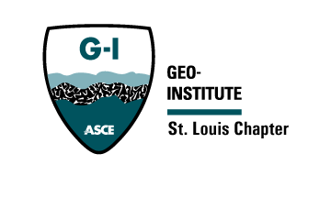


St. Louis Chapter of the Geo-Institute

Agenda

Meeting Date and Time: March 11, 2025

Attendance:

Meeting Location: TEAMS

- Structural and Geo-Confluence 2024
Financials: no update
Date penciled in for 2025 and draft contract. November 5th
- Finance Update, current Fiscal Year
Net positive of 17k
31k
- Scholarship Awardees
Notice sent
Zack to sent reminders
Alizadeh to be sent (dale smith and greg hempen). May increase amount
Likely due may 9th
Usually two students. On occasion 3
- Student Sponsorships
We did sponsor students
- Spring Seminar Event Discussion
  - Case Histories – Need to do call for abstracts
  - April 23rd
  - Call for abstracts went out
    - Was in ASCE news letter
    - No responses yet
    - Zack to make event
    - Zack to send poster announcements
    - Dr. Luna to reserved Il Monestero
      - Reserved 5-9
      - Doors open at 5:30
      - Dinner at 6:00
      - Student presentations 6:00-6:30
      - Presentations 6:30-8:30
        - 10 minute break between
- Adopt an Engineer
  - Had first student interaction early December
  - Could promote to young professionals
    - Maybe younger members group could promote
- University Program Updates Discussion for GI Chapter?
  - Zach will be following up on Student chapter coordinators – Did this happen?
- Next meeting:
  - Date and Time: TBD
  - Location: TEAMS

