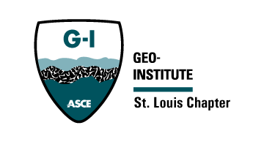


St. Louis Chapter of the Geo-Institute

Agenda

Meeting Date and Time: October 21, 2024, 3:00PM

Meeting Location: TEAMS

- Structural and Geo-Confluence 2024 – Updates
Terracon will fill one of the final meal sponsor spots for the conference.
One meal sponsor spot remaining.
No Structural exhibitor sign up. Looking to have 18 to 20 exhibitors.
GI will fully sponsor Geotech student minus the $5 fee.
Looking for volunteers to work greeting and sign-up table. Door opens at 6:40.

- Finance Update, current Fiscal Year
No update from section.

- Communications
No student has register for the adopt an Engineer. Generate advertisement strategy during conferences to inform student (flyers)
Add Shari Contact to constant contact to reach more students.
Extend outreach for adopt an Engineer to geological engineer students.

- Scholarship Awardees
Announces scholarship winner during the conference for those attending. Generate a slide to show during the conference.
Include a handout to provide attending announcing scholarship opportunities.

- Student Sponsorships
No request from students has come in.

- Adopt an Engineer
Slide during conference announcing the launch of the program.

- Best Chapter – Submittal
Due November 22, 2024
Send Photograph of GI event to Travis for inclusion in the Best Chapter

- Next meeting:
  - Date and Time: (November 20th – 8:00 to 9:00 A.M)
  - Location: Team
  - December meeting will be held December 12 before Section social events.

